

Welcome to Planet Eclipse

February 28, 2006
Mike Milinkovich 

The Mouse that Roared
No, I am not talking about one of my all-time favourite B movies. I'm talking about the Higgins announcement today. (Higgins being both a project at Eclipse and a Tasmanian long-tailed mouse.) In the press release, IBM, Novell and Parity Communications announced support for the Eclipse Higgins project. The announcement was widely covered by both the press and the blogs. If Parity Communications
by Mike Milinkovich at February 28, 2006 01:53 AM
Wayne Beaton 

Code Template Expansion in Eclipse
Eclipse is great for lazy folks like me. By typing just a few keystrokes and hitting "ctrl-space", Eclipse will generate a lot of code for you. For example, if you open a Java editor, move your cursor to a blank line and type "sysout", it will expand what you've typed into System.out.println() and conveniently put the cursor between the parentheses.
I tend to use "toarray" a lot. This one is handy for converting a collection type into an array; it changes "toarray" into (type[]) collection.toArray(new type[collection.size()]). Even better, it put focus over the replaceable bits in the template and lets you tab through them. At first, it will put focus on "type"; anything you type there will appear in both places the word "type" appears. When you hit tab, it will move focus to "collection". Very handy when you're up against Java weirdness (you have to admit that the mechanism for converting a collection into an array is just weird looking).
There are a lot more templates. You can see the list that applies to the Java editors in the preferences dialog (Java > Editor > Templates).
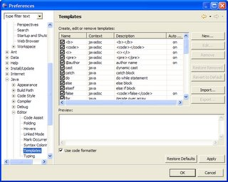
Go ahead. Be lazy. You're in good company.
by Wayne at February 28, 2006 12:32 AM
Wayne Beaton

Finally... a home for presentations, code, and other stuff...
I've made a new page on eclipse.org for evangelism-related stuff. Included there are presentations from events (including the Eclipse in Motion seminar), source code (so far, I've only posted the code for a that eBay RCP application I keep droning on about).
I'm going to try and add some spice to the page. First, I've included a few graphics (it's a start) including a tiny new vanity shot of yours truly. I haven't quite decided if the picture embarasses me or not. Time will tell. I'm going to add some pictures and I'm also going try to prune down the text so that the page isn't nearly so dull.
Anyway, I hope you enjoy the content.
by Wayne at February 28, 2006 12:08 AM

February 27, 2006
Ed Burnette 

Who do you trust more than Microsoft?
IBM and Novell announce donations of code and support for the Higgins open source identity management framework.
by Ed Burnette at February 27, 2006 07:54 PM
Wayne Beaton

WTPWUG Tuesday night!
Just a quick reminder that I'll be speaking at the RTP WebSphere Users Group on Tuesday night. I'm speaking about using Eclipse to develop and test applications on WebSphere Application Server and building front ends for those applications using Eclipse Rich Client Platform (RCP).
I have a presentation that should occupy a good chunk of the night, but I'm banking on folks having questions that will drive the talk in whatever direction it needs to go. I'm also planning to do a lot of demos.
So... there'll be WTB presenting WTP & RCP @ WUG in RTP. It's all just a little too much for an acronym-impared individual such as myself...
February 27, 2006 05:17 PM
Jonas Boner

Terracotta DSO Explained
Along with the 1.5 release of the Terracotta Server (shipped today), we have new web site along with a really good flash demo explaining our DSO (Distributed Shared Objects) technology.
It takes you through the concepts and ideas behind the technology as well as shows you a couple of live demos, definitely worth the 5 minutes it takes to watch it.
Just browse to the web site and click on [View Our Demo].
by Jonas at February 27, 2006 05:15 PM
Wayne Beaton

LinuxWorld Boston 2006
I sent in my talk for LinuxWorld Boston 2006 on Friday. Friday was the deadline and I do try to take deadlines seriously. As you can see from the fancy graphic on the left, the conference is in the beginning of April; I hate having to submit a talk so far in advance since I tend to tweak my presentations right up to the minute before I present. Still, I understand why the organizers want to have the talks, even if I don't necessarily agree it.
I'm not a huge fan of printed handouts for presentations. It gives me great pain to see the stacks of unused printed handouts destined for the landfill at the end of the conference. I try to craft my presentations so that there's not a lot of content on any single slide. I generally try to avoid lengthy chunks of code or anything that audience members cannot reasonably see from the projector. And... in my humble opinion, most of the interesting things that I say aren't in the slides anyway. You have to pay attention to me, not the handouts if you want to get value from the talk.
Anyway, I really hadn't intended for this blog entry to dissolve into a rant against printed handouts, so I'll move on...
I'm speaking on the topic of building applications using Eclipse Rich Client Platform (RCP). The hook for the LinuxWorld conference is the ability to deploy your applications on multiple platforms. I've done a lot of work on the talk and plan to continue to tweak it even though what I finally present will differ slightly from the handouts. If the situation permits, I'll run through the presentation during the Eclipse in Motion code camps this week and will be presenting at least some parts of it for the RTP WebSphere User's Group.
In the meantime, what do you think? Is the environmental impact of printing a bunch of handouts worth the value you get back from them? Do you actually keep the handouts? Do you throw them out before you leave, or after you get home?
by Wayne at February 27, 2006 05:10 PM

February 26, 2006
Bjorn & Ward 

Close Races in the Eclipse Community Awards
With only two more days of voting (voting ends Tuesday night), there's a landslide winner in the Top Ambassador category but it's neck and neck in the Top Contributor and Top Committer categories. Your opinion counts - more than you think! Only 169 people have voted - 83 committers and 86 community members - so if you vote now, your vote will be more than 1.2% of the vote total!
Nominees - now is the time to get out the vote - convince your public to vote for you as Top Contributor or Top Committer.
by Bjorn Freeman-Benson at February 26, 2006 11:12 PM
Chris Aniszczyk 

Eclipse in Motion: Raleigh
Here's a reminder that the Eclipse in Motion: Raleigh edition is coming up on the 28th. I have a eRCP in 15 minutes presentation prepared if we have time to go into it at the code camp. It all depends how prepared everyone is with questions :)
Also, feel free to shoot me an email if you're in the area to discuss Eclipse/Open-source over coffee (or a beer).
by zx at February 26, 2006 10:35 PM
Ed Burnette

Evangelist wanted, apply within
Are modern day software evangelists grass roots rebels or just re-invented marketers? The truth is somewhere in between.
by Ed Burnette at February 26, 2006 07:14 PM

February 24, 2006
Mike Milinkovich

GPLv3 Update
I thought I would mention a few early thoughts on the GPLv3 progress, and the impact it may have on the Eclipse community. (In other words, I am most emphatically not talking about the merits of the Free Software Foundation (FSF)'s proposed GPL revisions in general.) Janet Campbell from the staff of the Eclipse Foundation is actively involved as a member of "Committee A", so we are participating
by Mike Milinkovich at February 24, 2006 07:02 PM
EZ Tips and Tricks 

Generating good hashCode() and equals(Object) methods
Before we had Eclipse 3.2M5 if you wanted a good hashCode() or equals(Object) method your only options were to read a good book on the subject and implement the method, guess and implement it yourself and find out months later it was riddled with bugs or use Jakarta Commons-Lang utility classes used to build hashCodes or perform equals operations. 784 words. Read More at EclipseZone
by Riyad Kalla at February 24, 2006 03:01 PM
Philipp Tiedt

What is my selection ?
Do you know that problem? There is a view in Eclipse displaying some artficats and you want to contribute a new popup menu entry for them. So you go ahead and create a new objectContribution for the org.eclipse.ui.popupMenus extension point. The only question is, what object type do I want to contribute the entry for? How do I find out what kind of objects are displayed?
One way is to go and have a look at the source code of any view that displays this object and dig a bit in their label or content provider. Doing so you need to find out where the view is implemented and so on ...
I have written a tiny tool that should make things easier here and shows the type of the object selected. You simply right click an object in a view and select "Show selection".
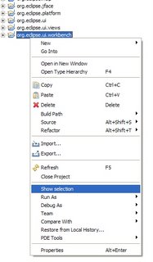
A small message box will pop-up presenting some information about the object you selected.
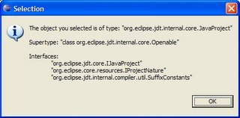Typically in your extension you would want to specify one of the interfaces for the object type to contribute a menu entry for.
To many people have asked me to tell them what type of object they are seeing because they want to contribute an action or menu. I was just sick of searching everytime :) You can download the plugin including sources here.
by Philipp at February 24, 2006 01:51 PM

February 23, 2006
Chris Aniszczyk

Friendly IRC Reminder
In an email sent to eclipse-dev, Doug Pollock reminds us that we should try to build a nice community for Eclipse on IRC
This is just a note to try to encourage Eclipse committers to use IRC. It's an excellent public forum -- both for helping users and for getting to know other committers. We're on Freenode (irc.freenode.net) and we maintain the following channels:
#eclipse - questions from plug-in developers and users
#eclipse-dev - Eclipse committer discussion and socializing
#eclipse-commits - lists all commits as they come in (cia.navi.cx)
We are also now registered as a group with Freenode.
So, please give it an honest try. The more people we have in #eclipse, the more people will likely get a quick response to their question.
by zx at February 23, 2006 09:47 PM
Wayne Beaton

Image View plugin
I do all of my editing of the pages on eclipse.org (including editing articles for Eclipse Corner) using Eclipse Web Tools. I personally don't mind looking at HTML, and the HTML editor provided with Web Tools is top-notch (a lot of the content on eclipse.org is represented in XML, which Web Tools handles quite well also). So, I basically have everything I need. Sure, I might like to have a fancier WYSIWYG editor, but I'm not one to complain.
I say basically, because there are a few things missing. I quite dislike having to leave the comfort of my Eclipse development environment to do things like manipulate image files and what-not. Especially since most of the things that I do to image files is pretty simple: resize and crop.
I had a couple of hours to kill while sitting on an airplane (I believe that I write more software on airplanes than anywhere else), so I started developing a couple of handy plug-ins to suit my needs. The first plug-in is an image viewer: all it does is display the selected image. I hooked into the workbench's selection service and listen for selection changes. If an image file is selected, the view displays it.
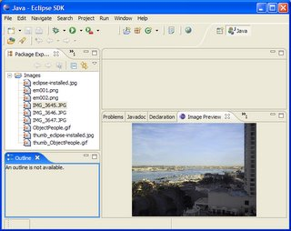
Here, it's displaying one of the pictures I took during the Eclipse in Motion roadtrip while we were in San Diego. The view displays a scaled-down version of the image. If you hover the mouse over the image, it pops up a window showing the image in its full-size glory. The full size image goes away when you move the mouse off the image or click it (I discovered that moving the mouse off the image just doesn't cut it when the image is larger than the screen). At some point, I may decide to add scroll bars, but I don't need them today so that'll be put off until some other time.
The next plug-in generates thumbnails (scaled down variants) of pictures. The first plug-in literally took me 20 minutes to build. The second one is taking longer for two reasons: (1) making a GIF thumbnail from a JPEG image (for example) requires that I somehow intelligently create an 8-bit palette; and (2) I've decided to build a wizard that steps the user through the various options for creating a thumbnail and I really hate laying out user interfaces. Number (1) may go away as I am very close to deciding that it's okay for a thumbnail to just be the same format (and use the same palette) as the original. Alternatively, I'm assuming that this is a problem that's been solved before and that with a little research there's probably a solution out there that I can leverage. Number (2) is going to be helped along by the Visual Editor.
Of course in a vibrant community such as ours, there are plug-ins and products that do this sort of thing already (plus a whole lot more). For example, MyEclipse has image editing and preview capabilities built into it. QuickImage appears to be about as functional as what I created (and is apparently bundled with Yoxos and Exadel Studio). Then there's "A Basic Image Viewer" on Eclipse Corner Articles (not a plug-in, but still interesting stuff).
I'll make my plug-ins available to anybody who wants them. I'm about mid-way through setting up an "Evangelism" site on eclipse.org where I can put stuff like this. Watch this space for more information.
by Wayne at February 23, 2006 07:51 PM
Kevin Parker

New Demo available
We have just posted a new version of the demo. It's a little more polished and shows all aspects of the Proof of Cencept code.
It also offers the choice of just seeing the demo or a version with a pre-amble and post-amble to give the demo more context.
We are working on how we can use some Open Source tools in the demo for EclipseCon and will start to show the ALF Eclipse plug-ins once they are in a worknig state.
Kevin
by Kevin Parker, ALF Project Evangelist at February 23, 2006 06:33 PM
Ed Burnette

Patent terrorists ruin an industry
A few software patents may be struck down but many more are ready to attack our creativity and slow our innovation.
by Ed Burnette at February 23, 2006 04:10 PM
Eugene Kuleshov

Jira support in Mylar.
Support for Jira queries has been included into the last dev builds of Mylar plugin. It is very basic and only allow to use filters saved in Jira web UI, but that is good enough to authomatically pull new issues/bugs as Mylar tasks.
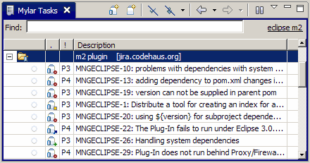
Update: Mylar 0.4.9 has been released. See New & Noteworthy page for all new features.
by Eugene Kuleshov at February 23, 2006 03:35 PM
Adrian Colyer

Tips for using Eclipse effectively
In Germany they have an entire magazine devoted to Eclipse, called (imaginatively ;) "Eclipse Magazin"". I don't speak (or read) German, but I have to say the content always looks really good, and they've had some excellent coverage of AspectJ and AJDT in past issues. The magazine has a guest column, "MyEclipse" in which various users of Eclipse describe their favourite hints and tips for working with the IDE.
It was my turn to write the column this month.
I have to say, I enjoyed writing the piece more than I thought I would - amongst other things it made we really think about how I actually do use Eclipse, and whether I'm using it as effectively as possible. The original column can be found here. With permission, I'm making an English translation (strictly, the English original!) available here for those that don't read German. If you have any favourite Eclipse tips that I don't know about, please do let me know!

My Eclipse
I’ve seen a lot of different people using Eclipse over the last few years. Nearly every one of them was using Eclipse pretty much in its default configuration. My Eclipse looks quite different to that, and in this article I’ll walk you through a collection of hints and tips for getting the most out of the IDE for Java development.
I’ll show you how to get organized when working with multiple workspaces, multiple projects, and lots of jar files. I’ll show you how to configure the IDE to help you write better code, and how to organize the Java perspective for maximum efficiency. As you might expect, I’ll also give you a couple of hints and tips for working with AspectJ!

Getting Organized
Using multiple workspaces
I tend to have multiple workspaces on the go at any one time (about 8 at present having just done a quick check). I use different workspaces for each major project (or version of a project) that I’m working with. For example, right now I’ve got workspaces for AspectJ 1.5.1 development, the AspectJ 1.5.0 release branch, Spring development, a couple of demonstration workspaces I use when giving talks, a workspace I use when giving training courses, and so on. It’s not uncommon for me to have 2 or 3 eclipses open at the same time.
The first practical question becomes knowing which eclipse is which when looking at the task bar or selecting between open windows using Alt-Tab. I always launch eclipse from the command-line using a script. Passing the “-showlocation” flag adds the workspace location to the windows title bar so that you can easily see which window is for which workspace. I normally start Eclipse with a little extra memory too (I find it works a little snappier that way). A good default for launching Eclipse if you’re working with sizeable projects would be something like this:
eclipse.exe –showlocation –vmargs –Xmx512m > /dev/null 2>&1
(I use cygwin, and I find that Eclipse tends to dump nonsense to the console that I don’t want to see, hence the redirect).
Another problem with using multiple workspaces is keeping your preferences and settings up to date across all of them. There is no need to configure each workspace individually every time you create a new one! Get one workspace set up exactly how you like it, and then select File -> Export -> Preferences. This will create a file that contains all of your preferences settings that you can keep in (e.g.) your home directory. Whenever you create a fresh workspace, use File -> Import -> Preferences and you’re good to go.
(By the way, if you're adding plugins to the base eclipse set, see Colin Sampaleanu's excellent blog entry on how best to manage that).
Coping with lots of projects inside a workspace:
It’s also not uncommon for me to have a lot of projects inside a workspace (one project per module). This is where working sets can make a big difference. Take a look at how the package explorer shows my core spring training workspace by default:
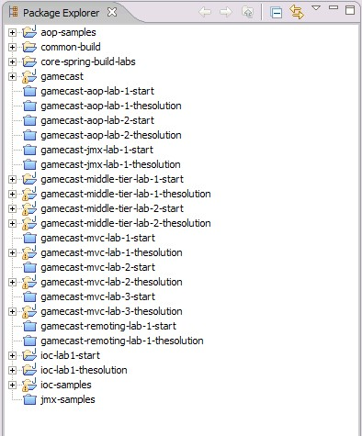
It’s just a jumbled mess of projects. Working sets to the rescue! From the drop down menu at the top right-hand corner of the Package Explorer view click on “Select Working Sets…”. From here you can define logical groupings of projects. With your groupings defined, select “Show -> Working Sets” from the drop-down menu. Now the Package Explorer will look something like this:
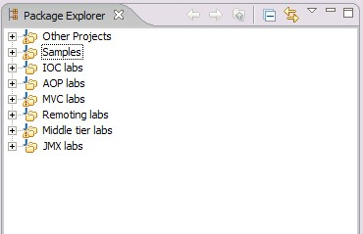
Much better!
Sorting out the clutter inside a project:
When looking at an individual project inside the package explorer, all of the jar files on the project build path show up by default. Most of the time I find these just get in the way. Here’s how my spring development workspace looks with the jar files showing:
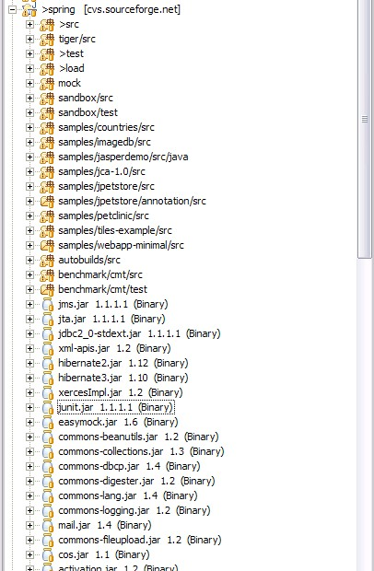
The list of jars goes on even further, and worse, there are additional folders that I do care about at the end of the list. Select “Filters…” from the Package Explorer drop-down menu and define a new name filter matching “*.jar”. This will hide all of these jars from view making it much easier to find what you really want.
Organizing jar files:
On the subject of jar files, if you have common groups of jar files it can be very effective to define them as “User Libraries” that can be named and added to a build path as a unit. You’ll find the settings page to define user libraries under “Windows -> Preferences…” and then select Java -> Build Path -> User Libraries.
Sharing projects with others:
To make projects easy to share with others (for example, checking into a shared CVS repository) make the maximum use of variables. Right next to the option to define User Libraries, you’ll find the option to define Classpath Variables. When adding an external library to a build path of a shared project, always define a classpath variable that points to the containing directory on your local machine (or just the jar file itself). Then you “extend” the variable when defining a build path entry. This way each user can define the variable appropriately for their own local environment, but the project settings can still be shared in the repository.

Using Eclipse for Java Development
Helping Eclipse to help you write better code:
I used to use a small editor font in order to see the maximum amount of code possible inside the Java editor window. A while ago I changed tactics. Now I use a larger font than normal – 14 pt bold. As a consequence, I can see a lot less code in the editor at a time. This helps me write better code.
Let me explain.
It’s natural to want to see a whole method in one go. Seeing less code on the screen at a time has the subtle effect of making me write shorter, clearer methods. It’s also easier to sit back and reflect on code, and easier to pair program and work with others. Give it a try and see if it works for you too.
Organising the Java Perspective:
It used to be that I was never satisfied with the width I’d set for the Package Explorer and JUnit views. Too narrow and I couldn’t see the package and type names properly, or the stack traces in a test failure. Too wide and the editor window would get crushed between the Package Explorer on the left, and the Outline View on the right. Especially if you follow my suggestion of using a bigger font this can be a real pain.
I found the answer in a combination of fast views and in-place views. Now my eclipse dedicates as much real estate as possible to the source code. I have no views on the right-hand side, and no views on the left-hand side. The views I typically work with are the JUnit View, Type Hierarchy View, Package Explorer, and Javadoc View. Open these views, right-click in the title bar, and select “Fast View”. By default fast views dock at the bottom of the screen, but it’s not as convenient to move a mouse up and down to open them as it is to left-to-right. Select the fast view bar and choose “Dock on… left”. You have now reclaimed all of the space on the left-hand side that these views used to take, and your perspective should look something like this:
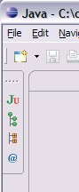
Another hidden benefit of this mode is that you can make the views wider than they were before, so that you can see the content properly (or even better for e.g. JUnit and Search, set the orientation to "horizontal" from the context menu). You can also set the widths of each view individually (JUnit wider than the Package Explorer for example, which is a significant improvement). If you don’t like having to move the mouse across to open a view, I’ll discuss a solution to that in a moment.
Any views you may have on the right-hand side, just close them (for most people, this means the Outline View). Instead use the in-place views. Ctrl-O opens an in-place Outline View (over the top of the editor). It’s actually better than the more usual docked view because it supports type ahead to quickly find the member you are looking for. Along with Ctrl-O, you also need to learn Ctrl-T which opens an in-place “quick” type hierarchy. This is a really easy way to see all implementers of an interface for example.
A final tip on the subject of view arrangement. If you have a dual monitor setup (becoming very common in the client sites I visit) it is quite nice to undock the Javadoc view completely – just grab it and drag it right outside of your Eclipse window and onto your second monitor screen. Now you’ll have the javadoc permanently open as a reference tool while you work. (Yes, you can undock views in Eclipse now, a lot of people seem not to know that).
On the subject of key bindings, you can significantly improve your productivity in Eclipse by learning some of the basic keyboard short cuts for common tasks (and indeed, for some things in the Java editor that aren’t available from the menus at all). However it’s also true that some of the default bindings for common tasks are absurd: “Alt-Shift-X,T” to run a test case for example – one of the tasks you’ll be doing very frequently I trust. When using fast views, I also find it convenient to add key bindings to open the Package Explorer and JUnit views quickly without having to move the mouse at all.
I make the following changes to the default key bindings:
Key combination | Result
Ctrl-P | Open the Package Explorer (normally bound to print, but I hardly ever print from Eclipse, and will happily use the menu for that)
Ctrl-R | Run as a test case. (normally bound to run-to-line in the debugger). Running tests should be a simple key-stroke away at any time.
Ctrl-J | Open the JUnit View (normally bound to incremental search)
Ctrl-I | Incremental search
Ctrl-G | Generate getter/setter
Ctrl-B | Toggle breakpoint
Now that you have Ctrl-R to run tests, it’s worth knowing that you can use this shortcut from within the editor when editing a test case, when a package is selected (to run all the tests in the package), when a source folder is selected (to run all the tests under the source folder), and when a project is selected (to run all the tests in the project).
Here are some of the other key shortcuts that I find amongst the most useful:
You’re already familiar with using the arrow keys (left,right,up,down) to move around within the editor. Using the arrow keys in combination with Alt, Shift, and Ctrl put a whole new set of capabilities at your fingertips:
Key combination | Result
Arrow keys | Move cursor point in editor
Shift + arrow keys | Increase/decrease selection in editor
Alt+Shift + left,right | Select previous syntactic element / next syntactic element
Alt+Shift + up, down | Select enclosing element / restore last selection
Ctrl+Shift+left,right | Select next word / previous word
Ctrl + left,right | Move left / right by one word
Ctrl + up,down | Scroll up / down by one line
Ctrl+Shift+up,down | Go to previous member / go to next member
Alt + left, right | Go forward and backward in history (really useful if you’ve been following links exploring the code)
Alt+up,down | Hidden treasure! Move the current line or selected lines up and down
Ctrl+Alt+up,down | Duplicate line above / below
Other useful keys (standard cut/copy/paste etc. not included as I assume you are already familiar with these):
Key combination | Result
Ctrl+O | In-place outline view
Ctrl+T | In-place quick type hierarchy
Ctrl+M | Maximize/restore current window/view
Ctrl+D | Delete line
Ctrl+Shift+delete | Delete to end of line
Shift+Enter | Insert new line below
Alt+Shift+R | Rename
Alt+Shift+T | Quick refactoring menu
F3 | Open declaration
F4 | Open in type hierarchy
F11 | Debug last launched
Ctrl+F11 | Run last launched
Ctrl+Shift+T | Open type
Ctrl+Shift+R | Open resource
Ctrl+Shift+G | Search for references in workspace
Ctrl+F6 | In-place editor selection
Ctrl+F7 | In-place view selection
Ctrl+F8 | In-place perspective selection
F12 | Activate editor (useful if you’re following my suggestion of using fast views :- F21 will dismiss the fast view and return you to the editor)

AspectJ hints and tips
Eclipse has great support for aspect-oriented programming with AspectJ through the AJDT plugins. In this section I’ll show you how to set up projects using linked source folders, how to run JUnit tests with an aspect library using load-time weaving, and some things you can do with the Visualizer that you may not realise. See the AJDT site on Eclipse.org for a tutorial on using AJDT – this section just contains a few less-well-known pointers.
Before we start, if you’re trying out using fast views and closing all the views on the right-hand side, one of things you’ll be missing is the cross-references view from AJDT (with all of the advises and advised-by relationship information). You can either dock this at the bottom (alongside the console for example), or use the in-place quick cross references view (not a lot of people know about that!). It has a not-very-useful default key binding of Alt-Shift+P, I remap it to Ctrl+U (not many letters left to choose from!). Now just press Ctrl+U anywhere in the editor and get a pop-up view of the cross-references for the selected element. Press it again to get cross-references for the whole file. Perfect!
Linked source folders:
Linked source folders can be a great way to experiment with aspects on a project without touching the main (Java) project at all. Create an AspectJ project alongside the Java project that you want to work with. Put all of your aspects into the “src” folder of the AspectJ project. Now, inside the AspectJ project open the project properties (Alt+Enter, since we’re trying to wean you off the mouse!) and go to the Java Builder page, and then the “Source” tab. Click on “add folder” to create a new source folder, and then the “Create new folder…” button. Here you’ll see an “Advanced” button. If you press this, you’ll get the option to create a folder that is actually a symbolic link to another location. Use this technique to create source folders inside the AspectJ project that are symbolic links to the source folders inside the Java project you want to work with.
Now whenever you build the AspectJ project, you will get (in the bin directory of the AspectJ project) a woven version of the project files. You will also see any warnings or errors arising from your use of declare warning / declare error in this project. The “donor” Java project remains completely unaffected by this exercise. Any changes to the source files in the Java project are of course instantly visible in the AspectJ project (and vice versa). To get the best performance, you can now turn off incremental building for the AspectJ project (Project menu -> build automatically) and just build that project on demand using the AspectJ build button in the taskbar.
Load-time weaving
(See my entry on using an aspect libraryfor a more in-depth treatment of this)
If you’re using an aspect library (such as spring-aspects.jar that ships with Spring 2.0) it is very convenient during development to use “load-time weaving”. Load-time weaving is the name given to weaving your application classes at runtime as they are loaded into the virtual machine. In this way there is no need to convert your project to an AspectJ project, or to do anything special at all other than put the aspect library on your build path.
Say you have some integration tests that you kick off via JUnit, and that rely on the behaviour contributed by the aspects in order to pass. For example, you’re using @Configurable to dependency inject domain objects. With the needed library on the build path, create a launch profile for the test run. The easiest way to create a launch profile is just to highlight the test or set of tests that you want to run and run them with Ctrl+R (if you’ve followed my advice and remapped that key binding). This run will fail, because you haven’t activated load-time weaving yet. Now select “run…” from the launch menu and you’ll see the launch profile that was created for the tests you just ran. Click on the arguments tab, and in the “VM arguments” box add the following:
-javaagent:aspectj-install-dir/lib/aspectjweaver.jar
Where aspectj-install-dir is the directory where you installed AspectJ (it’s best to download the standalone compiler and associated tools from www.eclipse.org/aspectj when using load-time weaving, ant building etc..).
Now you can rerun the tests and you’ll find that AspectJ picks up and uses the aspect libraries that you have on your classpath. It really is as simple as that.
Visualizer:
One of the tools that you get when you install AspectJ is the Visualizer. In fact, you get a whole “Aspect Visualisation” perspective which is the best way to use the visualiser. By default, the visualiser shows you cross-cutting information such as advises and advised by relationships. The visualizer plugin actually provides a generic capability that is not tied to AspectJ though. Open the visualizer perspective, and from the drop-down menu of the main visualizer view select “preferences”. Here you can choose the data provider that the visualizer will use to display information. By default it uses the AspectJ provider as I said. If you change to the “JDT Search Results Provider” you can use the view to visualize the results of the current search (all the matches, and where they are in the project).
The following image shows the results of searching for references to “InitializingBean” in Spring. Just as with the advice visualization, you can navigate from the visualization to the source code locations simply by clicking on the bars.
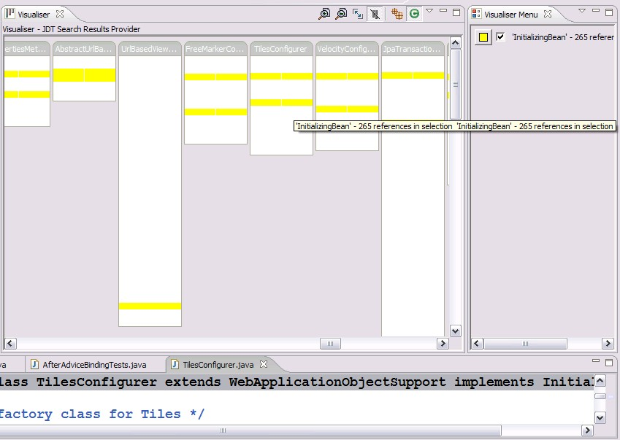
If you select “Resource and Markers Provider” you can see where all of your breakpoints, Task markers, warnings and errors are. Clicking on the options in the visualizer menu enables you to choose the subset of these that you are interested in at the time:
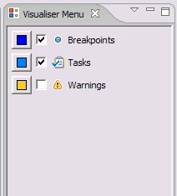

And finally
If you haven’t done so already, you should check out the Mylar plugin for Eclipse (developed by one of the AspectJ team, Mik Kersten) (see www.eclipse.org/mylar, and then go to the getting started page and watch the flash videos there). Especially if you’re working with bugzilla, Mylar is fantastic. Mylar deserves an article all of its own so I won’t attempt to describe it here – just go and try it out for yourself, you’ll be glad you did!
February 23, 2006 10:12 AM
Shaun Skelton

Exploring the Flexibility of Perspectives
As evidenced by over 67 pages of preferences and other configurable options, Eclipse is a very flexible platform; this flexibilty is matched in the user inteface through the use of perspectives. Perspectives define the set and layout of views and shortcuts in the workbench window. While developing a template for the perspectives extension I was able to explore the true power of perspectives. The easiest way to see their flexibility in action is by going through the "Customize Perspective..." pages in the Window menu. The majority of the UI's dynamic content can be modified using the three submenu selection windows on the Shortcuts tab and the numerous options on the Commands tab. An interesting exercise is to turn off all the standard options for a perspective and only add back the ones you intend to use; then save the perspective and use it for a while to see if you begin to use the shortcuts more now that you know where they came from.
When all the options are turned off through the custmization of the perspective, the views that remain are the contributions of the defining perspectives extension. The extension references a class file that is responsible for adding the various views, action sets, and shortcuts. The common method for adding views is to create an IFolderLayout with some position relative to the editor area and use the methods IFolderLayout.addView(String viewId) or IFolderLayout.addPlaceholder(String viewId) (adding a placeholder sets where the view will show up if it is enabled by the user at a later time). The best way of finding view ids is to look through the ui packages for the various platform components and find the id given in the views extension; additionally, the ids are sometimes given as API constants for the various packages. Then, calls to IPageLayout.addActionSet(String actionSetId) will provide the content for the menus and the toolbar and calls to IPageLayout.addNewWizardShortcut(String id) will provide the options shown when the user selects File > New. Again, the required ids can often be found as API constants or by looking at the id given in the respective extension of the various ui packages.Finally, calls to IPageLayout.addShowViewShortcut(String id) will populate the list of rapid navigation views in the Window> Show View submenu and calls to IPageLayout.addPerspectiveShortcut(String id) will generate the list of perspective options for the Window > Open Perspective submenu.
An example of this process can be seen in the class PDEPerspective where the steps are laid out quite logically and are easy to follow. I highly recommend playing with perspectives in order to experience just how much control is provided over the layout and presentation of the user interface.
For more information regarding perspectives, visit the online Help documentation .
by Shaun at February 23, 2006 04:26 AM
Michael Scharf

What does eclipse API freeze mean?
The eclipse 3.2 APIs have been frozen. John Arthorne has send a mail to eclipse-dev@eclipse.org:
Between now and the 3.2 release, all changes to API require the following action before releasing any code:

- A bug report describing the change, and the reason it is required.
- Approval from a PMC member (in the form of a +1 on the bug report).
Also, if it is a breaking API change, you should search for references across the SDK, and coordinate the release with any clients that have already adopted the API being broken.
The PMC has asked Boris Bokowski and I to track API changes during this period. Please also CC either Boris or myself on the bug so we can keep track of the changes.
by Michael Scharf at February 23, 2006 01:26 AM

February 22, 2006
Chris Aniszczyk

Comedy
I haven't been able to write much lately (I'm on the job transition phase of my life), but here's an interesting tidbit of Eclipse trivia. Guess who owned Eclipse.org before Eclipse did?
by zx at February 22, 2006 09:52 PM
Mike Milinkovich

Calling all Europeans!
Check this out. The publishers of EclipseMagazin in Germany have created a 20,000 euro award program for "Outstanding European Contributions on Java and Eclipse". Very exciting!
by Mike Milinkovich at February 22, 2006 03:45 AM
Ian Skerrett

Medical Banking on Eclipse
The Medical Banking Project just announced they have selected Eclipse as the platform for their reference implementation. I think it is great to see vertical oriented organizations adopting Eclipse. In my mind vertical frameworks is an important part of the future of open source software and Eclipse.
by Ian Skerrett at February 22, 2006 02:30 AM
Birt World

Top N/Top M% BIRT Report Example
A new solution report example has been added to the BIRT website that shows off new filtering functionality. New operators were added to the BIRT filters, which allow you to specify Top N or Top M Percent of data results.
In the example there is a graph that list the Top N customers. This is achieved by setting the filter to use the Top N operator. This is pictured below:
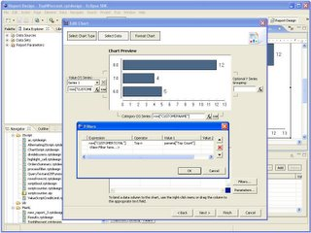
So this graph is taking the Customer Totals and filtering on the Top N, where N is passed in as a parameter to the report.
This report also has a table that list the Top M Percent Customers. This is achieved similarly to the graph and is pictured below.
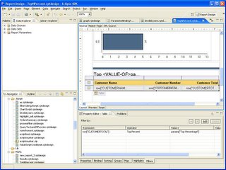
The final report is shown below. You can download the report from the BIRT Website
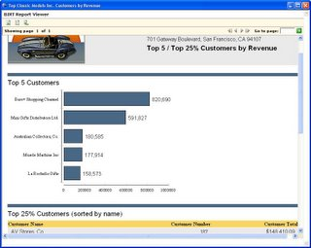
by Jason Weathersby at February 22, 2006 01:03 AM

February 21, 2006
Ed Burnette

Is your IDE *too* helpful?
One side-effect of IDE competition is that each team tries to outdo each other at every revision. Usually this is good, but sometimes... I'm not so sure. Consider this example.
by Ed Burnette at February 21, 2006 07:46 PM
Bjorn & Ward

Eclipse Awards, part 2
Another quick reminder about voting for the Eclipse Community Awards, Individual Category. The voting ends on February 28th, so be sure to get your votes in - it takes just a minute or two and everyone in the extended Eclipse community is eligible to vote. The winners will definitely thank you!
As a side note, I googled for "eclipse awards" and discovered that we should have had a few more categories such as "Best Two-Year Old Male", "Best Owner", and ...
by Bjorn Freeman-Benson at February 21, 2006 07:16 PM
Donald Smith 

Eclipse demand up over 25% so far in 2006
As you may recall from an old post, I believe that Dice.com is a pretty darned good indicator of real world demand for technology skills. Back in early January I noted that "Eclipse" had 490 job offers, JDeveloper 95, NetBeans + "Net Beans" 41, IntelliJ 27.
Well, just a few weeks later and Eclipse is at 622 jobs, JDeveloper is up strong also to 129 jobs. IntelliJ is up a bit to 32 and Netbeans + "Net Beans" is down to 31.
Ajax is really taking off, it's gone from 272 in early Jan to 432 today. Ruby went from 66 to 104.
After my last blog I received a lot of pings asking for help on hiring Eclipse talent. My recommendations are to post to the eclipse.employment newsgroup, or to try online at a place like Dice, Monster, HotJobs. When I did hiring at Oracle I had pretty good luck from each.
- Don
by Donald Smith at February 21, 2006 07:16 PM

Information
Planet Eclipse is a window into the world, work and lives of Eclipse hackers and contributors.
Looking for an RSS Newsreader? Try RSSOwl, it is built on Eclipse!
Last updated: February 28, 2006 06:10 AM (UTC)
Powered by:

Subscriptions
- Adrian Colyer (feed)
- Andre Oosthuizen (feed)
- Benjamin Booth (feed)
- Bill Dudney (feed)
- Billy Biggs (feed)
- Birt World (feed)
- Bjorn & Ward (feed)
- Bob Foster (feed)
- Boris Bokowski (feed)
- Chris Aniszczyk (feed)
- Chris Gross (feed)
- David J. Orme (feed)
- Denis Roy (feed)
- Donald Smith (feed)
- Doug Gaff (feed)
- Doug Schaefer (feed)
- Douglas Pollock (feed)
- EZ Tips and Tricks (feed)
- Ed Burnette (feed)
- Ed Burnette (feed)
- Eric Barroca (feed)
- Eugene Kuleshov (feed)
- Frank Sauer (feed)
- Gunnar Wagenknecht (feed)
- Ian Skerrett (feed)
- Jonas Boner (feed)
- Kevin Parker (feed)
- Kim Horne (feed)
- Lars Gersmann [Orangevolt] (feed)
- Levent Gurses (feed)
- Luis de la Rosa (feed)
- Martin Perez (feed)
- Matt Conway (feed)
- Michael Scharf (feed)
- Mike Milinkovich (feed)
- Nathan Gervais (feed)
- Patrick Paulin (feed)
- Peter Friese (feed)
- Philipp Tiedt (feed)
- Philippe Ombredanne (feed)
- Ryan Lowe (feed)
- Scott Schram (feed)
- Shaun Skelton (feed)
- Tim Wagner (feed)
- Tod Creasey (feed)
- Vasanth Dharmaraj (feed)
- Vineet Sinha (feed)
- Wayne Beaton (feed)
- Wayne Beaton (feed)
- Wenfeng Li [Birt Reporting] (feed)

About
If you would like your blog added to the feed, please file a bug against the planet with your feed specific information.
Maintained by the Planet Eclipse admins.

